Camera that follows car
Go on window by moving mouse to it.
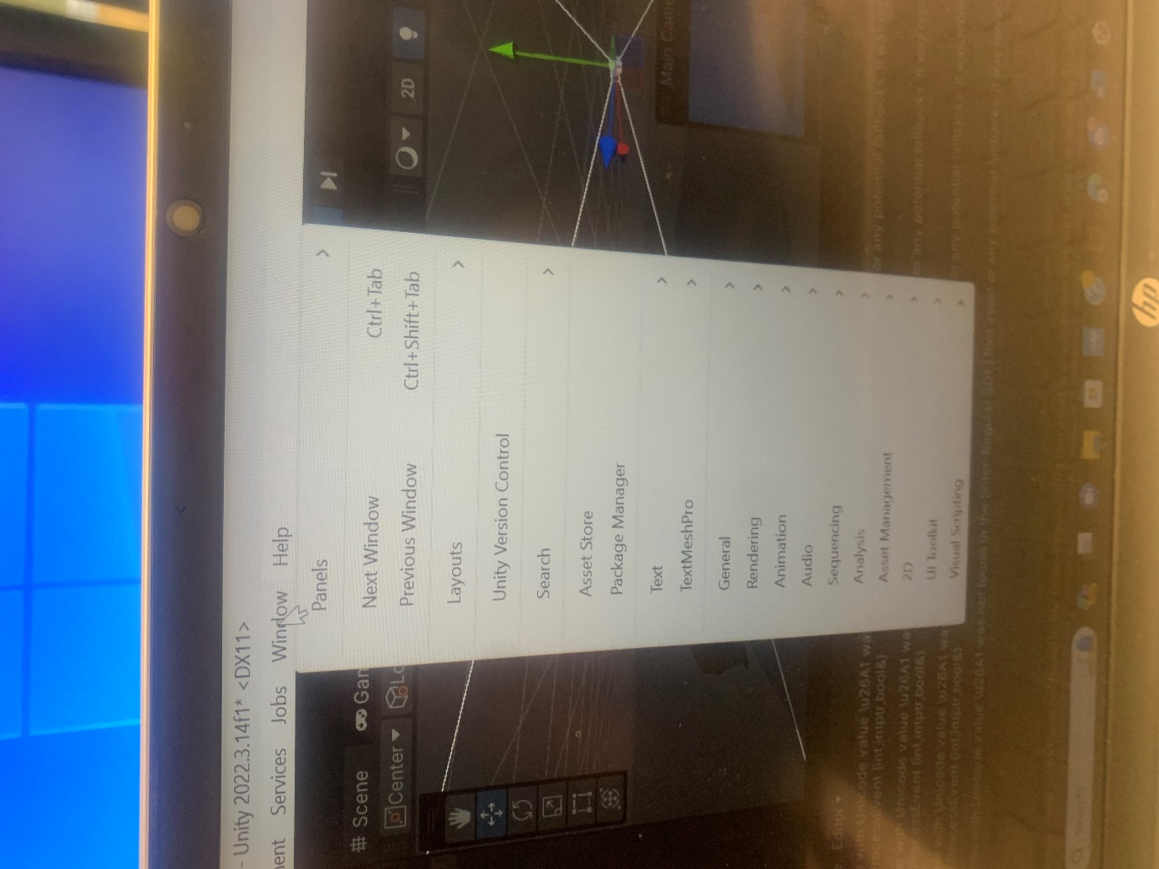
Press left mouse on package manager.
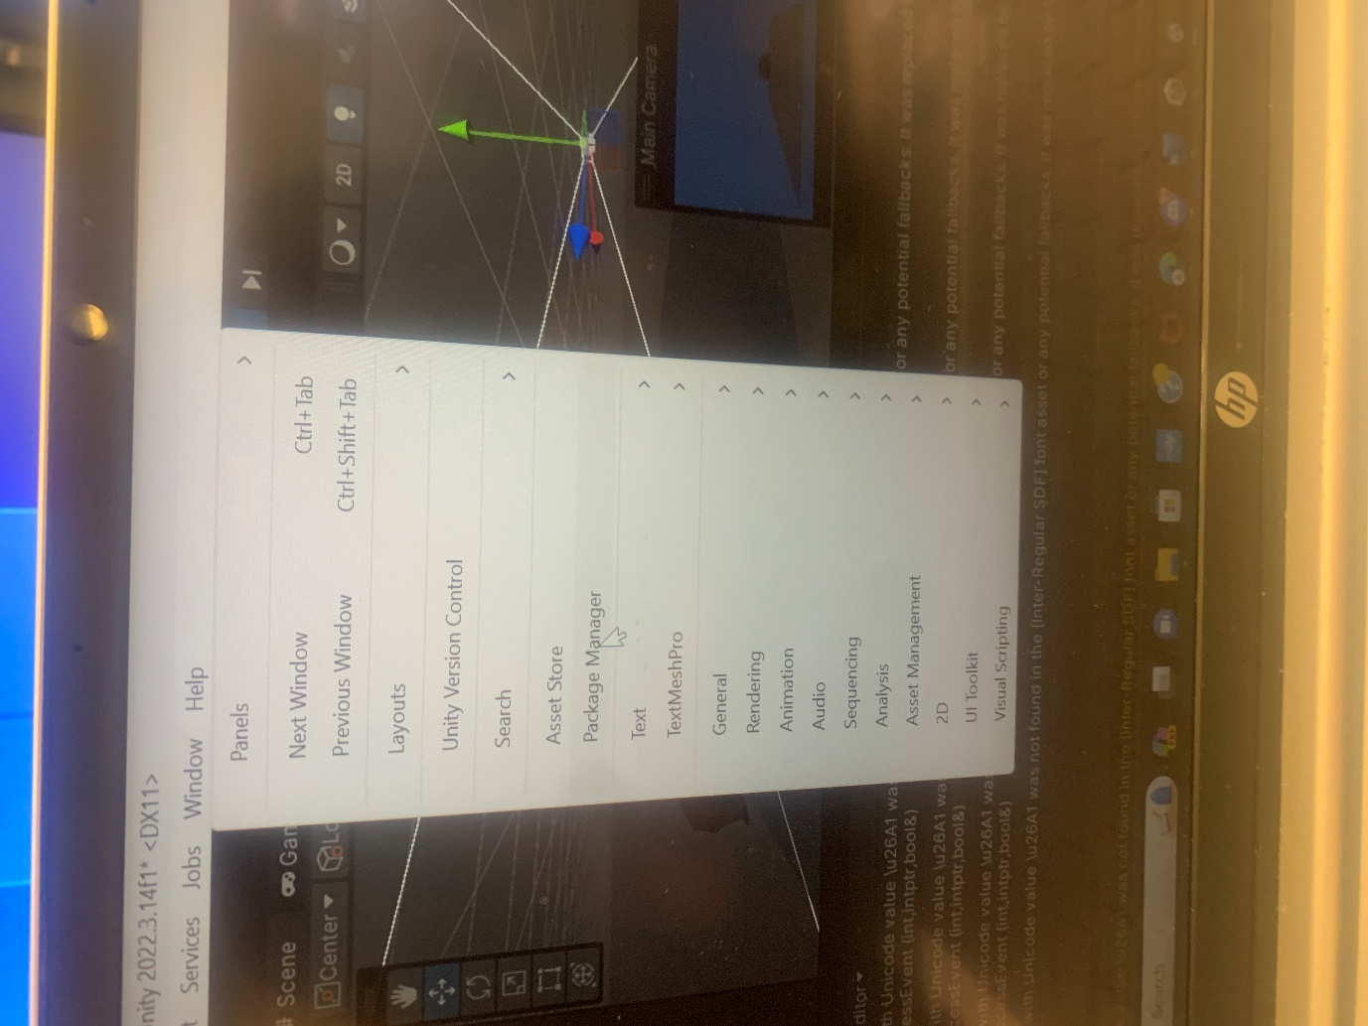

Type cinemachine and press install
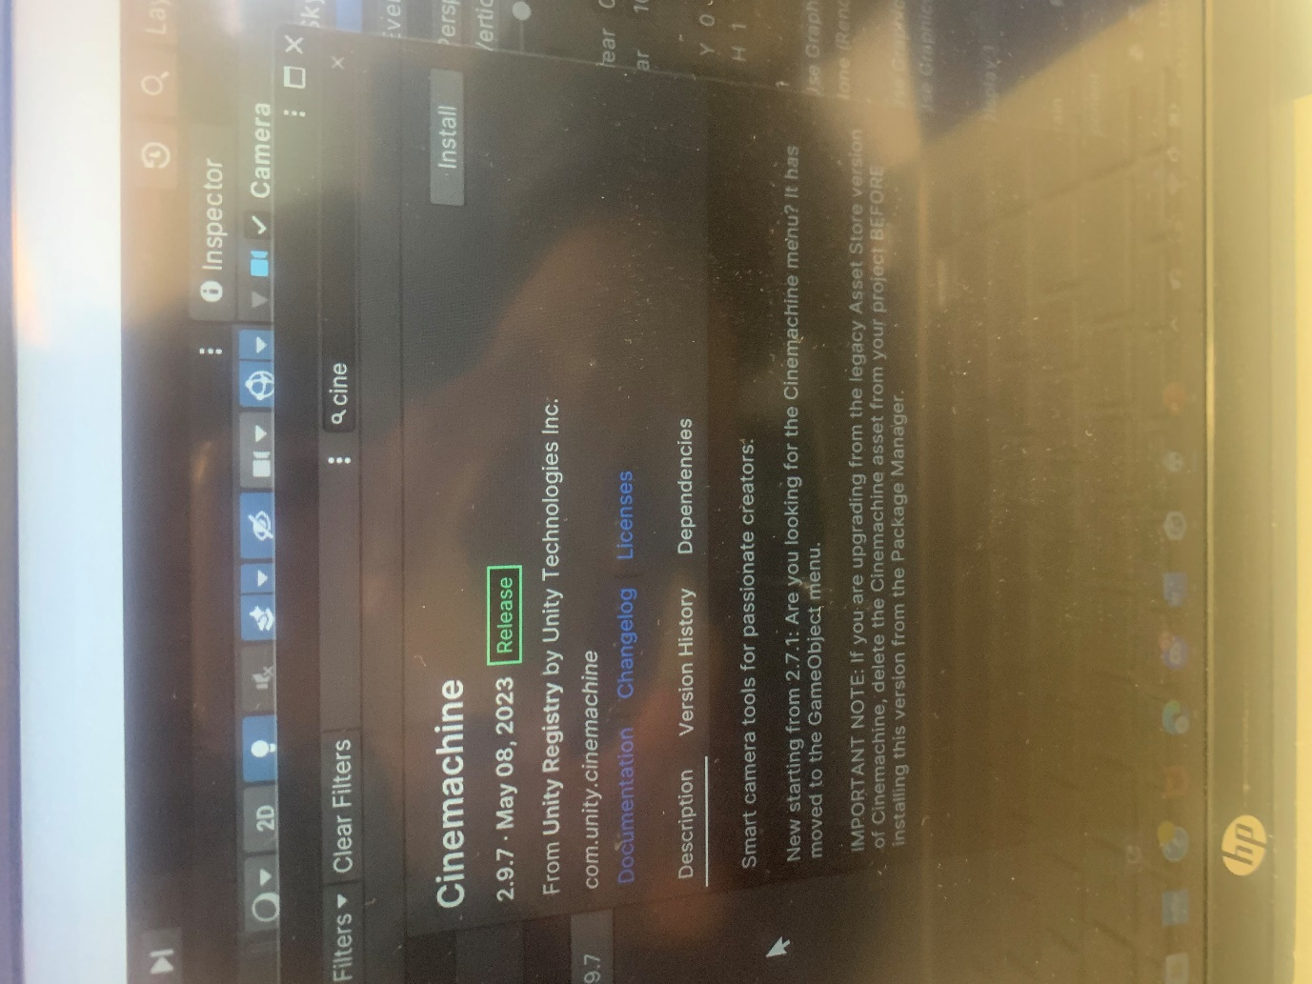

Press add component and type in cinemachinebrain and press cinemachinebrain.
